Process Definition Document
Of
Password Reset Automation
For
Mahindra & Mahindra

FEAT SYSTEMS PVT LTD.
1st Floor, Building-A, Suashish IT Park,
Dattapada Rd, Borivali East,
Mumbai, Maharashtra 400066.

Team Details:
Name | Designation | Contact | Email

Key Contact Person:
Name | Designation & Company | Contact | Email

Contents

1. Introduction 4
What is PIGEON? 4
Why PIGEON? 4
2. Process Overview 5
3. Scope 6
4. Process Map 6
Process Map 6
5. Detail Process Steps 8
5.1 Input 8
5.2 Process 8
5.3 Output 9
6. Rules 10
6.1 Handled Scenarios 10
7. Exception(s) 10

Introduction

The Process Design Document describes the business processes chosen for implementation of PIGEON ICQRS (Intelligent Customer Query Response System) and automation using the UiPath Robotic Process Automation (RPA) technology.
The document describes the sequence of steps performed as part of the business process, the conditions and rules of the process prior to automation and how they are envisioned to work after automating it, partly or entirely. This specifications document serves as a base for developers, providing them the details required for implementing PIGEON ICQRS and apply robotic automation to the selected business process.
This Process Definition Document (PDD) captures the flow of Password Reset Process for Mahindra & Mahindra to implement PIGEON ICQRS and configure a Digital Employee with Robotics Process Automation (RPA).
The document captures flowchart of the business process which is to be automated including process details. On the basis for the automation of the target process, the flowchart and assumptions are used as a platform based on which the solution is designed.
Changes to this business process may constitute a request for change and will be subject to the change procedures.

What is PIGEON?

PIGEON-iCQRS is an Omnichannel “Intelligent Customer Query Response System” designed with “customer first mentality” and important attributes of intelligence as well as better customer service in mind. It works for ITSM & CSM both.
With PIGEON-iCQRS, a customer need not wait for 12 long hours but get an instant response to his queries. Using the latest AI and Machine Learning skills and providing an integrated approach, PIGEON can understand your customer’s needs very efficiently. When customers require empathetical solutions for their queries, the Virtual assistant can direct such queries to a human expert whose workload will be tremendously decreased.

Why PIGEON?

- One-stop-shop solution for entire process transformation
- Reduce Manual efforts by nearly 80%
- Improve work efficiency by almost around 200%
- Quality improvement with nearly 0% error rate
- Improvement of Service levels from 10min to 1 min
- Improved staff retention by reduced high volume low value work to focus on complex/higher value work activities

Process Overview

The process is about resetting user password in Active Directory. In Mahindra & Mahindra user sends mail regarding password reset in active directory. Once the mail is received in BMC remedy tool, the engineer has to manually read the query and validate the correct user to reset the password. User then classifies the query and post that he resets the password, engineer has to reply the new password in trail mail to the user.
Below table gives and overall idea of the process
# | Item | Description
1 | Process full name | Password reset in Active Directory
2 | Process Area | Customer relationship
3 | Department | Customer Support
4 | Process short | Identify the mail related to Password rest in BMC remedy tool and process the request of resetting password in Active directory. Post resetting password send a reply mail along with new password to user
5 | Process schedule and frequency | Daily 300 to 400
6 | # of requests processed/month | ~ 9000 to 10000 requests per month
7 | Average handling time per item | 8 min
8 | SLA / TAT | 4 hours
9 | Peak period (s) | Every Monday
10 | Input data | Mail received in BMC remedy tool requesting password reset
11 | Output data | Reply mail to the requestor containing new password and also sending SMS on the registered mobile number

Scope

- Application Involved: Outlook, Active Directory, Excel.
- Organisation Involved: Tech Mahindra, Feat Systems.
- Frequency of Process: Daily
- Trigger from: Mail

Process Map

These sections include all the steps taken by bot to execute the process. As soon as the mail arrives in the mail box, PIGEON identifies the right query from BMC remedy tool and classifies it into respective category. Uipath Bot then extracts data from that mail, such as: ‘From’ mail Id, Mail Id’s in CC, Date of mail received, Time of mail arrived and Token Id from mail body.
Once bot reads all the mail data it will open active directory and will search for “Users, Contact & Groups” in drop-down list of Find option also selects the “Entire directory”.
If the CC of the mail does not have any mail id’s, then bot will check for the domain name. If the Token id is from Mahindra EXT domain then only bot will proceed further to reset the password.

Process Map
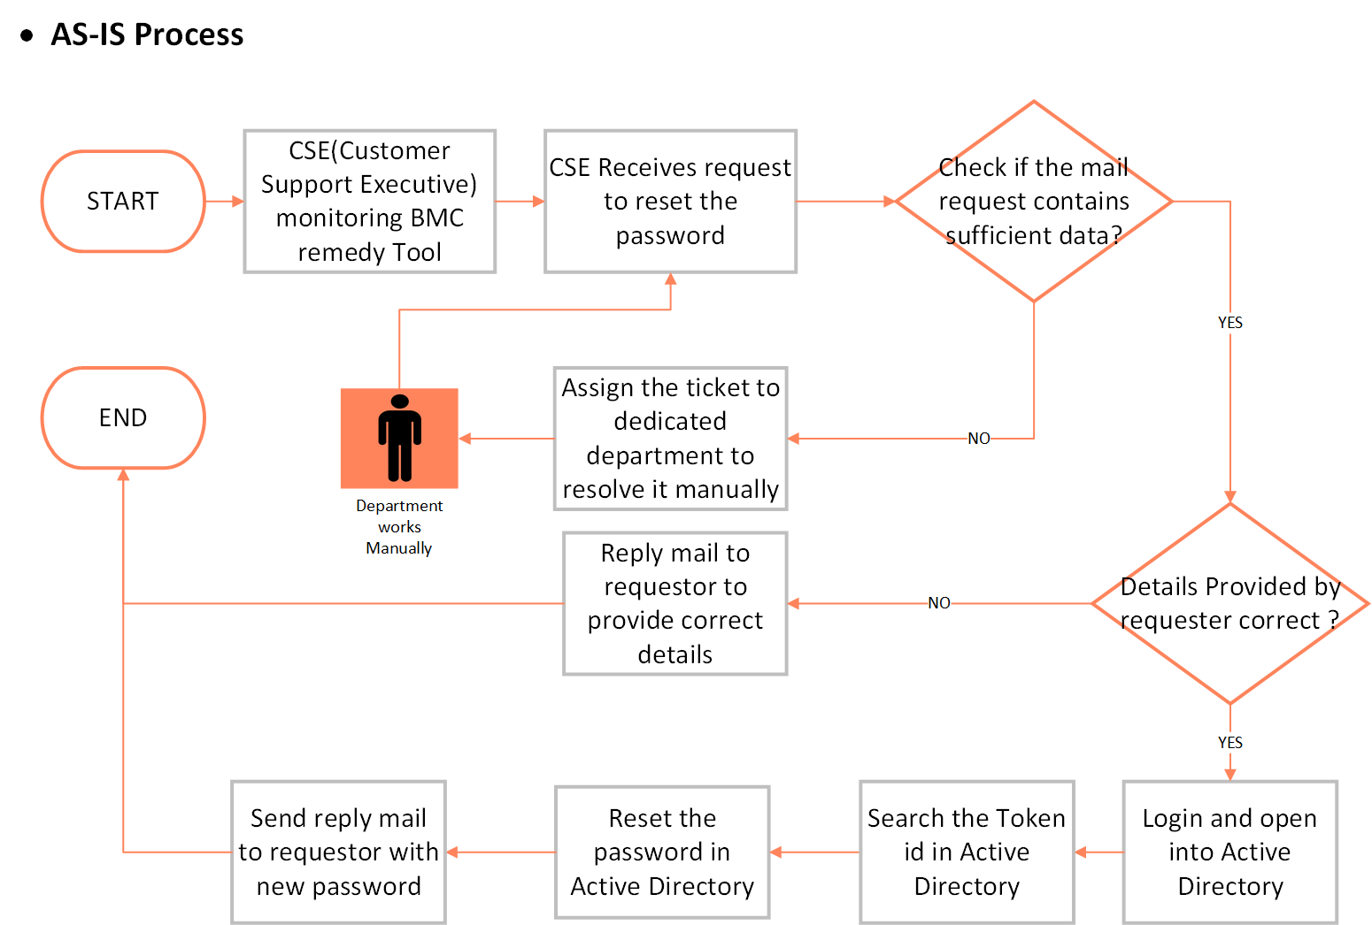
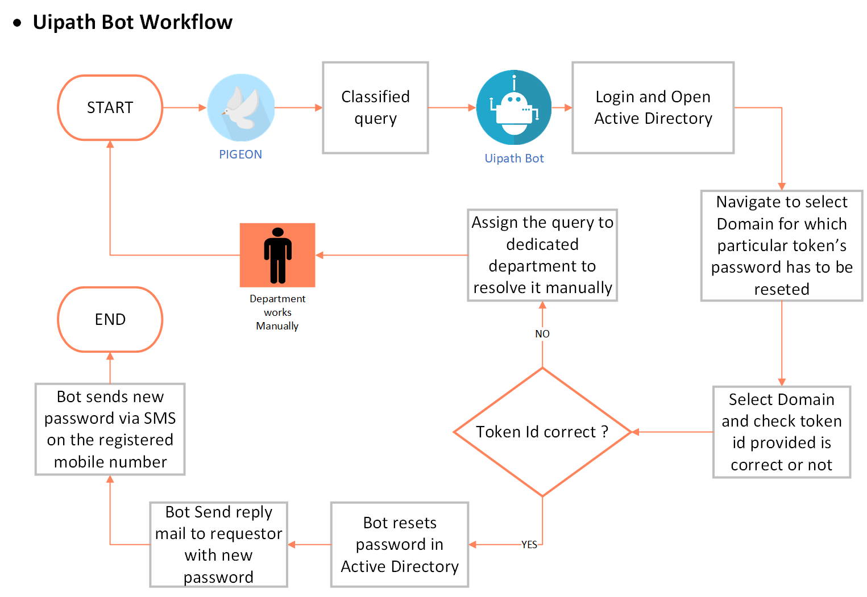
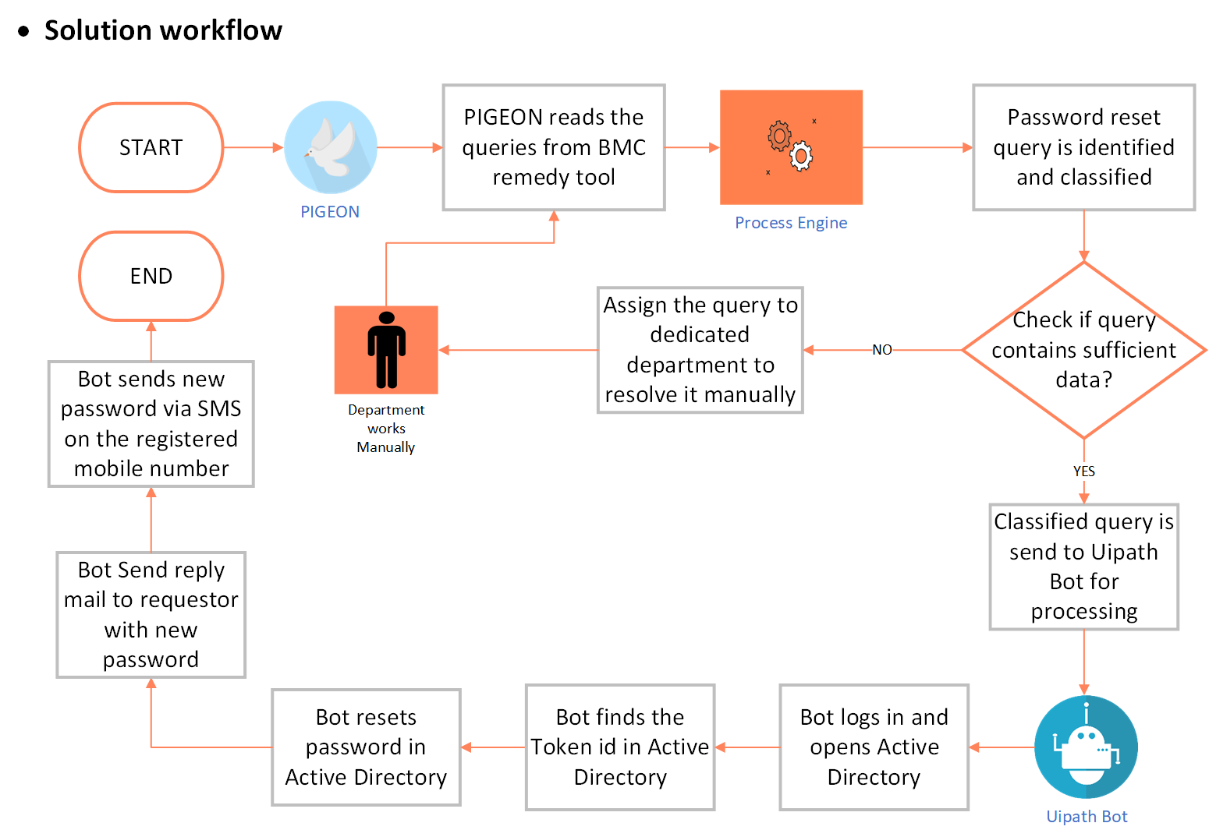

Detail Process Steps

Input

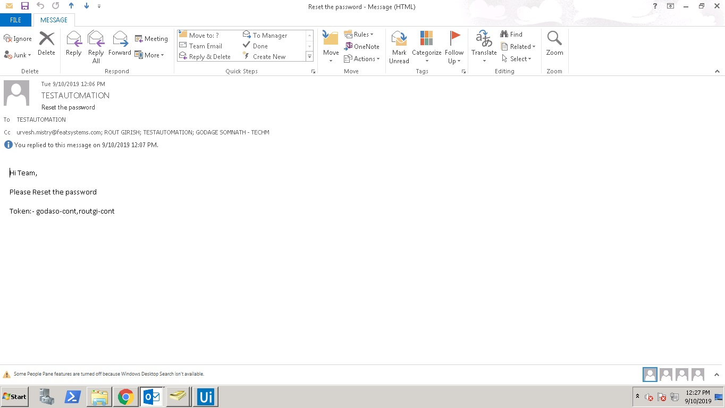

- Details of data Bot receives from PIGEON:

- From mail id | - CC mail id’s | - Date if the mail
- Time of the mail | - Token id’s | - Classified Domain name

Process

- Open Active directory.
- Click on the search user button which is located in the toolbar.
- Select “Users, Contact & Groups” in Find drop down list and also select “Entire Directory” in In Tabs.
- Enter the token is extracted from the mail body in “Name” textbox.
- Click “Find Now” Button and you will get the required user on the screen.
- Next, we have to validate the token id with respect to the mail id in the CC and check it in Active directory.
- Double click on the user we have searched and check the mail id whether it is marked in CC or not.
- Next, we have to extract the mobile Number of the user with respect to the mail id in the CC and check it in Active directory. Click on “Telephone” tab to extract the mobile number.
- We will find the Mobile number of the user under” Telephone” Tab. We will be sending the New generated password to the user via SMS.
- Close the window and right click the user name to reset the password.
- Click “Reset Password” to reset the password of the user
- Type the new password and click the checkbox shown in below image and click “OK” to reset the password.
- Click on the “OK” button to confirm and close the application.

Output

- As this process is only related to password resetting the process takes several minutes to resolve the query manually. So as to make these processes relevantly faster and increase the resolving rate, PIGEON ICQRS and Robotic Process Automation can play a huge role.
- PIGEON can help in providing better customer experience and fulfil the SLA as well as help in minimize TAT
- Automation can help the process go fast, accurate, minimise human errors and easy to evaluate.
- The output of these process includes resetting the password of provided token id’s in Active directory and replying the user in same mail with updated password.
- Sending SMS on registered mobile number containing new password

Rules

A rule constrains some aspect of business rules and handled scenarios in the business process. Business rules are intended to control and influence the behaviour of the business. Here rules are stated below that are handled during processing business process.

Handled Scenarios

- Single Token id and user in CC.
- Multiple Token id’s and multiple user’s in CC.
- Single Token id and multiple user’s in CC.
- Multiple Token ids of EXT domain and no user in CC.
- Single Token id of EXT domain and user in CC.
- Incorrect and Blank Token id.
- Correct Token id in combinations i.e. Ext Domain User and Normal Domain user
- Token id’s separated in various combinations (Example: Token id-1, token id-2, Token id-3; Token id-4).
- Password reset request from another domain
- Incorrect subject in the request email.
- Logging the request that have been performed in Excel.
- SMS API integration For Password Reset for User (if mobile number exists)
- Implementation for Ext Domain is done on the Server having only One Domain as Active Directory hence we have considered same domain for both scenarios i.e. Normal domain and Ext domain.

Exception(s)

- Delay in SMS due to SMS gateway/Service Provider issue.
- Outlook permissions issue while reading mail and sending mail.
- If MS Office is not activated, it results into corruption of Excel Files which may lead to process exception i.e. Log file

